**HOW TO REMOVE DUPLICTE ENTRIES FROM A DATASET IN EXCEL**

Duplicates are bound to be found in large datasets, especially when people have access to the same document, this makes data redundant. The larger the dataset the higher the chances of encountering duplicate records.

Before removing duplicate values, is wise to find, highlight and review them before removing them.

**IDENTIFYING DULICATES**

USING CONDITIONAL FORMATTING

1. Select the range of cell you want to check for duplicate.
2. On the Home Tab, click on conditional formatting, hover around the arrow and select duplicate values.

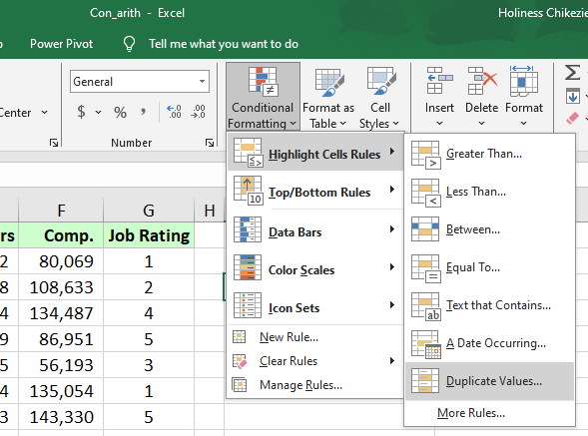

1. Customize how you want the values to appear.

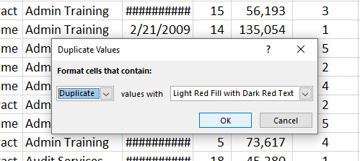

1. Click ok.

**REMOVING DUPLICATES**

1. Select the range of cells you want to check for duplicates.
2. Go to ‘Data’ tab, click on ‘remove duplicate option’.

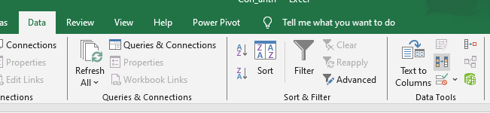

1. Check all the columns you want to remove duplicates from, and click ok.

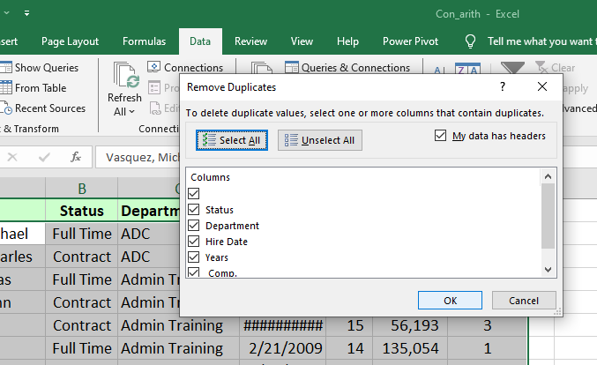

**USING THE FILTERING METHOD**

1. On the Data tab, in the sort and filter group, click advanced.

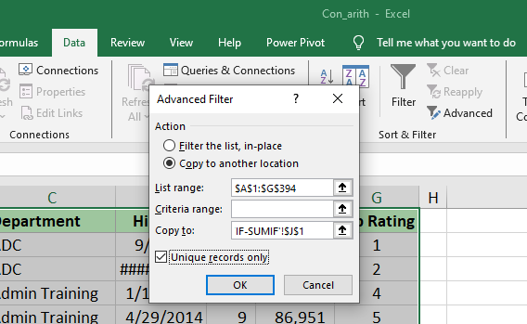

1. The advanced dialogue box appears, click copy to another location.
2. Select the range of cells you want to check for duplicates.
3. Click on the copy box and select on the sheet where you want your values to appear.
4. Check unique records only, and click ok.

